Postgres DB Mult-AZ Setup with Failover and SNS Notification

Summary: This project is a from Chapter 7 of “AWS DevOps Engineer Professional: Certification Gude”, by Sumit Kapoor (2024).
This is a quick project that has the reader create a Postgres DB, configure high availability settings and sns notifications using AWS CLI. I used PowerShell and Git Bash from my laptop to interface with the AWS CLI.
This project then concludes with a test of sns\email notification when testing the Postgres DB is rebooted.

First, I created the database in the AWS Console:
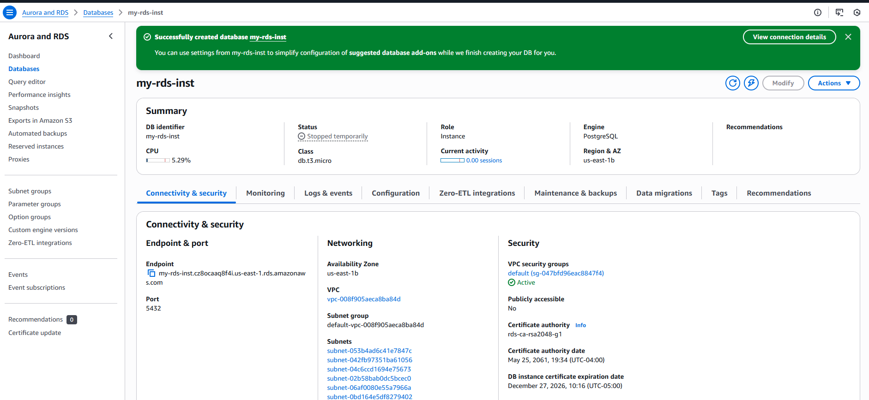

I then ran a command in PowerShell to determine if the DB instance is running multiple availability zones

I then ran a command in PowerShell to configure the DB to use multiple availability zones
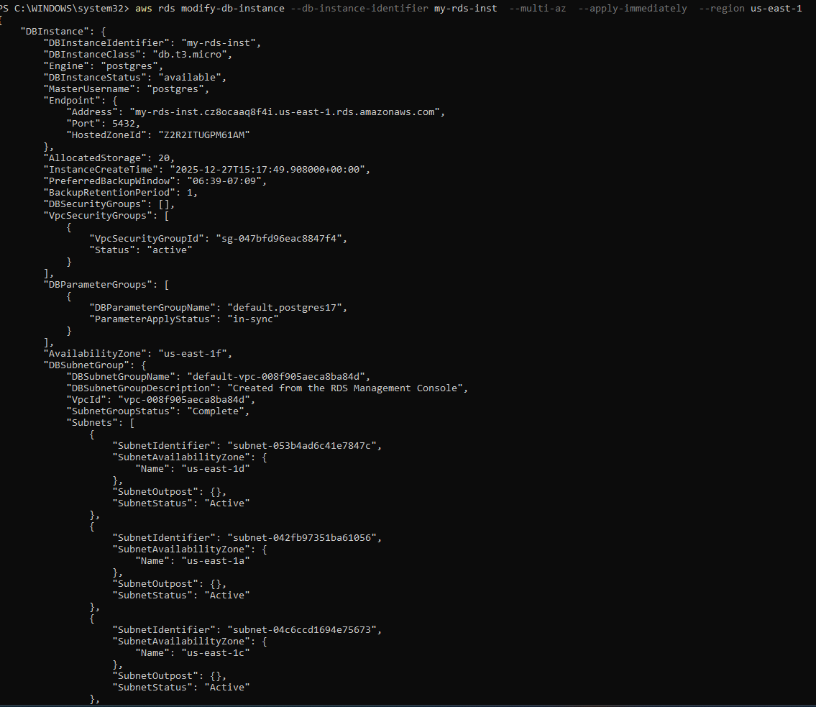

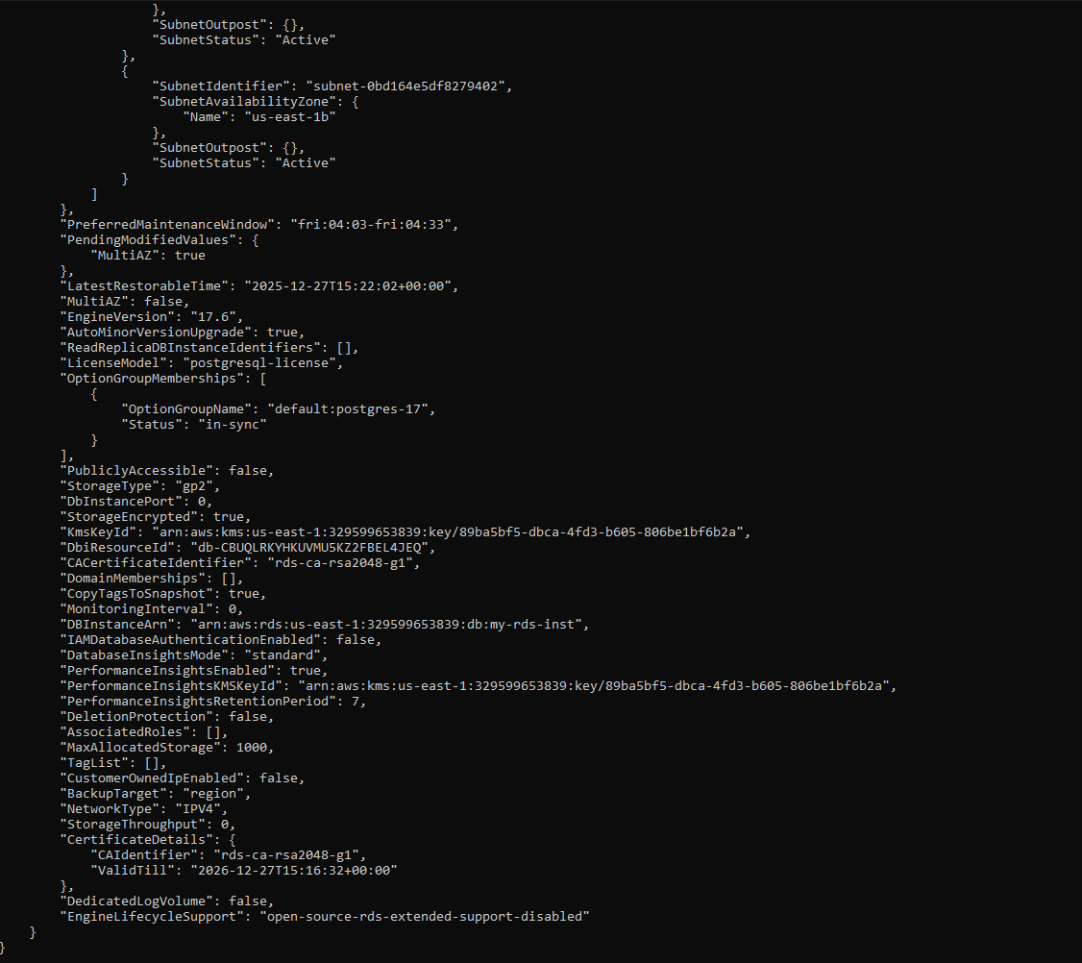

I then wrote a bash script that would create an event subscription when an email account is ran with the script

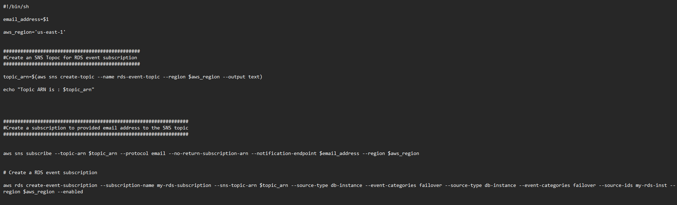

I then ran the bash script through Git Bash on my machine
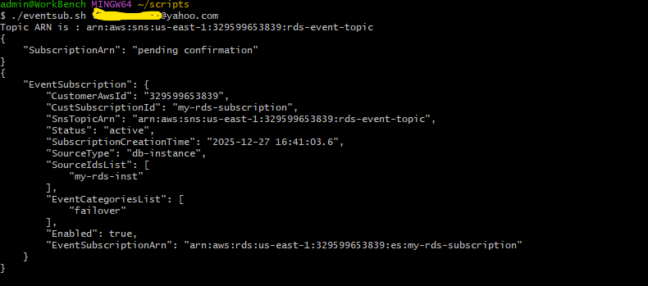

The event subscription was created for my test database, and I confirmed the subscription from my email address
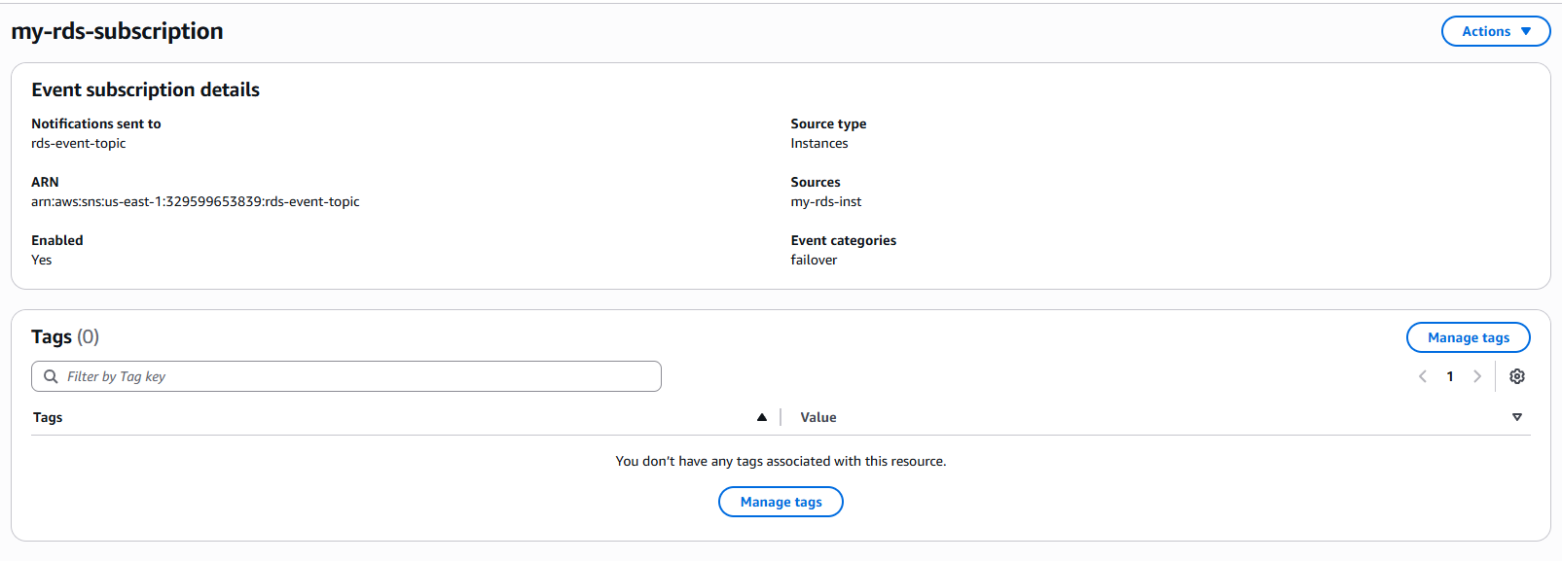

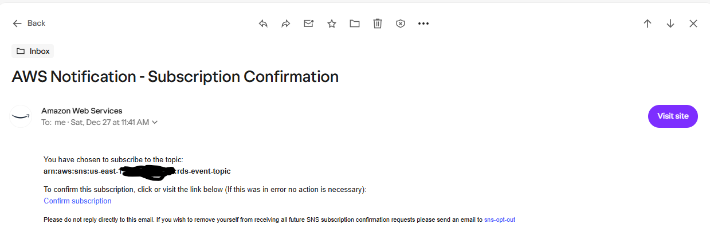

The database was then rebooted from the AWS console to trigger a failover event to test multi zone failover and the email notification configuration

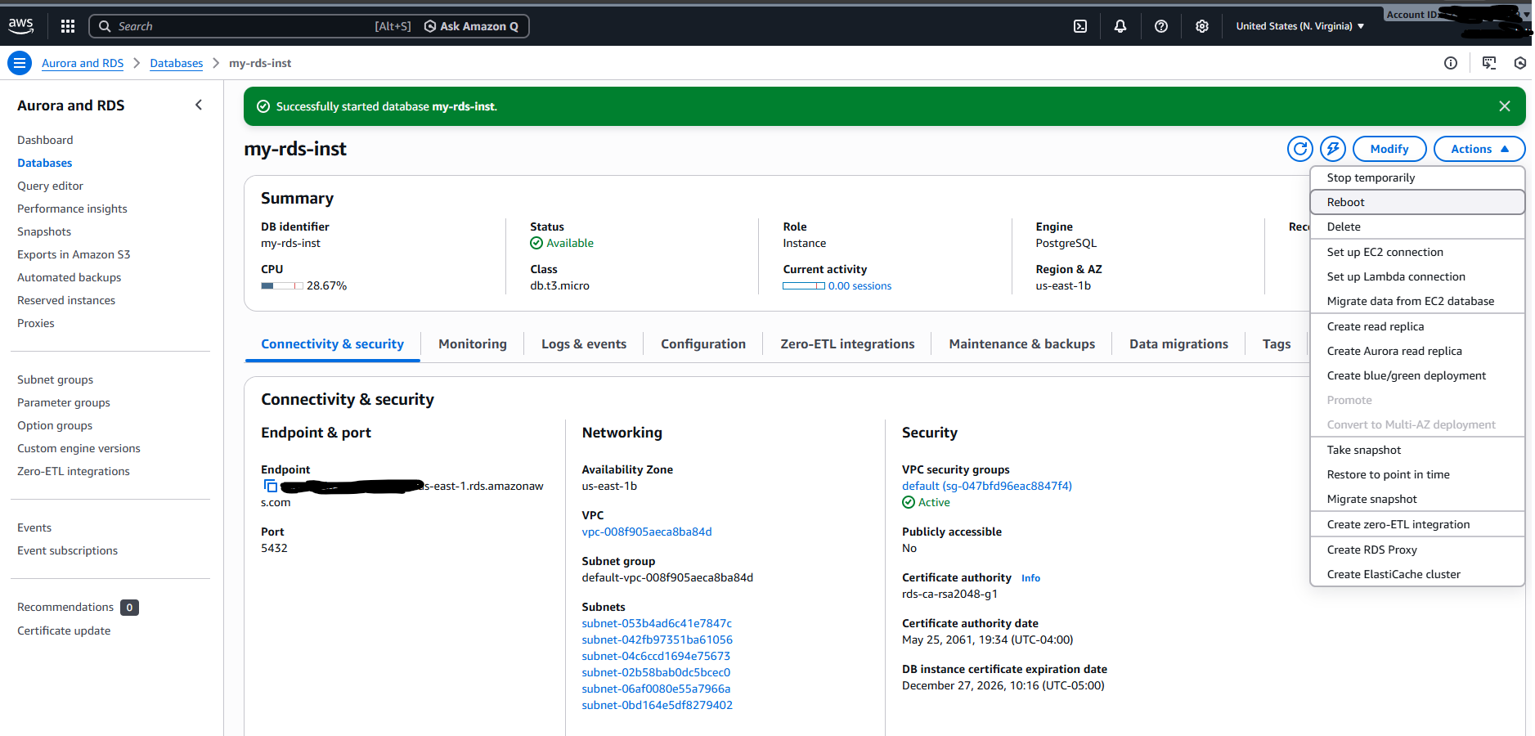

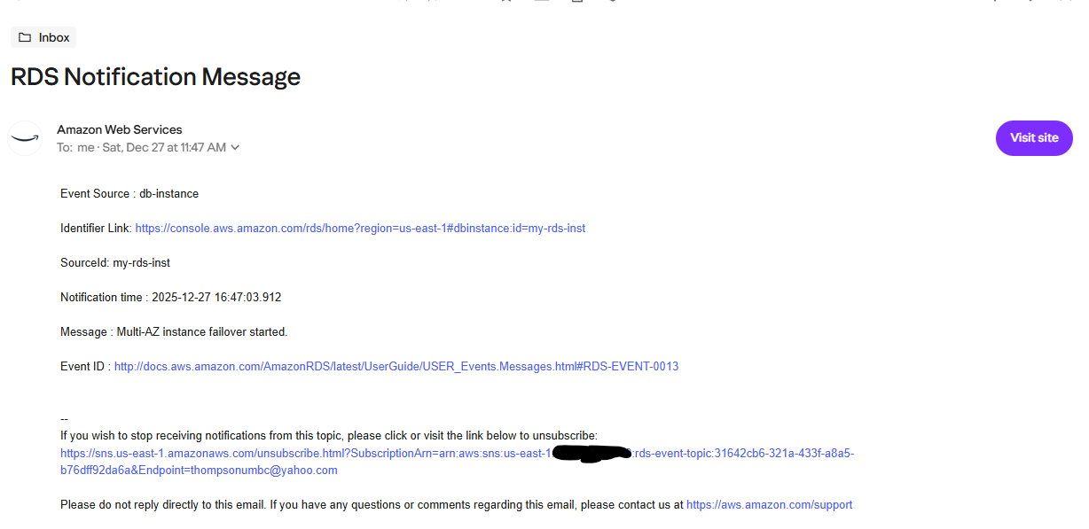

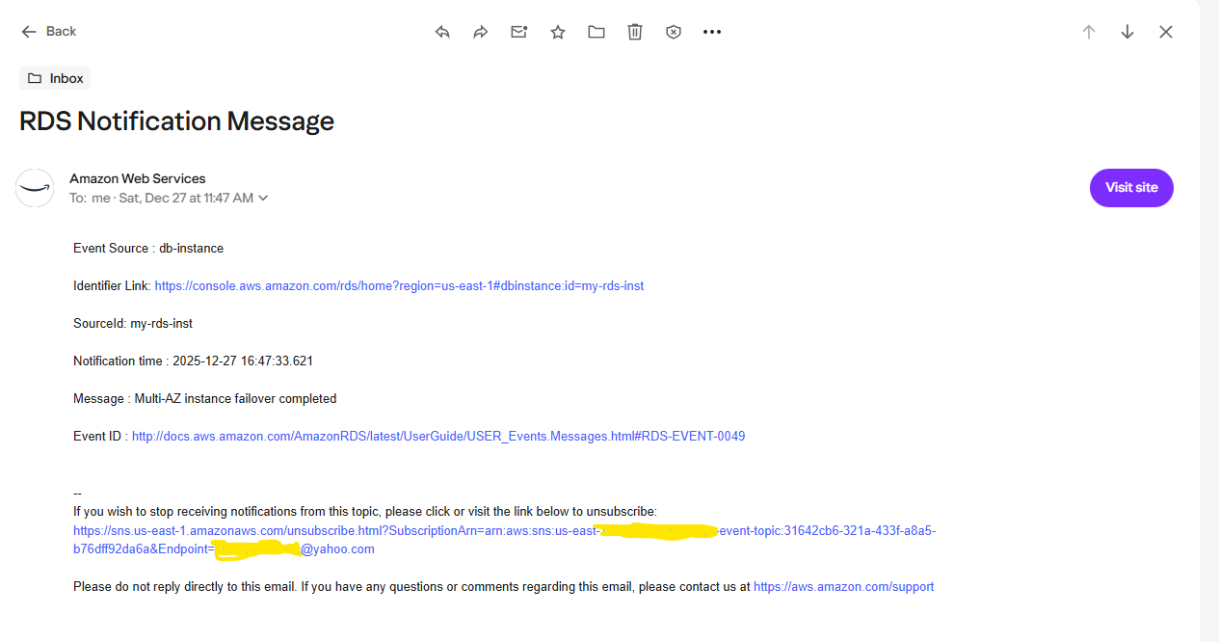

An environment like this in a production or test environment would benefit multiple parties at an organization.

These are examples of how different parties would benefit:
Developers: Email notifications would alert them the development/test environment is down
SRE/Engineers: The SRE team or Cloud Engineers would be notified of a down database, which should decrease response time to resolve an issue.
Customers/End Users: Customers can be assured their production environment can still continue in the event of a regional AWS failure or specific database issue. This should create a circumstance where the business impact is minimal.

